pf lab assignment #10

Mohammad Yehya Hayati, 21K-3309

Table of Contents

**Question #1** 2

**Question #2** 3

**Question #3** 4

**Question #4** 5

**Question #5** 7

**Question #6** 9

# **Question #1**

#include <stdio.h>

float power(float _num , int _p);

int main()

{

float num;

int p;

printf("Enter your number: ");

scanf("%f",&num);

printf("Enter the power: ");

scanf("%d",&p);

printf("The value of num^p = %f",power(num,p));

}

float power(float _num , int _p)

{

float res = 1;

if (_p == 1)

{

return _num;

}

else

{

res = _num * power(_num,_p-1);

return res;

}

}

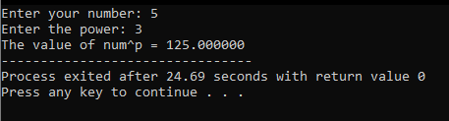

# **Question #2**

#include <stdio.h>

void evenoddprint(int _start , int _end);

int main()

{

int start,end;

printf("Enter the start: ");

scanf("%d",&start);

printf("Enter the end: ");

scanf("%d",&end);

evenoddprint(start,end);

}

void evenoddprint(int _start , int _end)

{

if (_end >= _start)

{

printf("%d\t",_start);

evenoddprint(_start+2,_end);

}

}

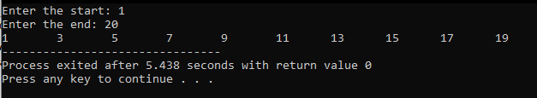

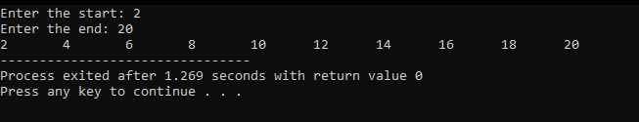

# **Question #3**

#include <stdio.h>

struct phone

{

int area;

int ex;

int num;

};

int main()

{

struct phone p1 = {212 , 767 , 8900},p2;

printf("Enter area code: ");

scanf("%d",&p2.area);

printf("Enter exchange: ");

scanf("%d",&p2.ex);

printf("Enter number: ");

scanf("%d",&p2.num);

printf("My number is (%d) %d-%d\n",p1.area,p1.ex,p1.num);

printf("Your number is (%d) %d-%d",p2.area,p2.ex,p2.num);

}

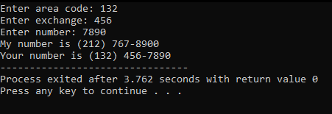

# **Question #4**

#include <stdio.h>

struct Students

{

int student_id;

int stu_age;

char stu_name[100];

int streetno;

char state[100];

char city[100];

char country[100];

};

int main()

{

int n;

printf("Enter number of students: ");

scanf("%d",&n);

struct Students s[n];

for (int i = 0 ; i < n ; i++)

{

printf("Enter student ID: ");

scanf("%d",&s[i].student_id);

printf("Enter student age: ");

scanf("%d",&s[i].stu_age);

printf("Enter student name: ");

getchar();

gets(s[i].stu_name);

printf("Enter street number: ");

scanf("%d",&s[i].streetno);

printf("Enter state: ");

getchar();

gets(s[i].state);

printf("Enter city: ");

gets(s[i].city);

printf("Enter country: ");

gets(s[i].country);

printf("\n");

}

for (int i = 0 ; i < n ; i++)

{

printf("Student ID: %d\n",s[i].student_id);

printf("Student age: %d\n",s[i].stu_age);

printf("Student name: %s\n",s[i].stu_name);

printf("Street number: %d\n",s[i].streetno);

printf("State: %s\n",s[i].state);

printf("City: %s\n",s[i].city);

printf("Country: %s",s[i].country);

printf("\n");

}

}

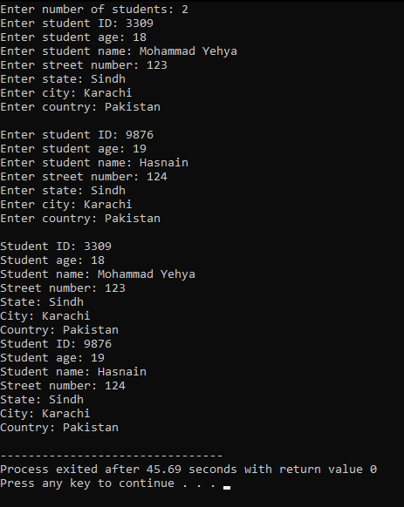

# **Question #5**

#include <stdio.h>

struct employee

{

int empcode;

char name[100];

int doj;

};

int main()

{

int n,curdate,i;

printf("Enter how many employee: ");

scanf("%d",&n);

struct employee emp[n];

for (i = 0 ; i < n ; i++)

{

printf("Enter employee %d code: ",i+1);

scanf("%d",&emp[i].empcode);

printf("Enter employee %d name: ",i+1);

getchar();

gets(emp[i].name);

printf("Enter year of joining of employee no.%d: ",i+1);

scanf("%d",&emp[i].doj);

}

printf("Enter the current year: ");

scanf("%d",&curdate);

printf("The employees with a tenure of 3 or greater are:\n");

for (i = 0 ; i < n ; i++)

{

if ((curdate - emp[i].doj) >= 3)

{

printf("%s\n",emp[i].name);

}

}

}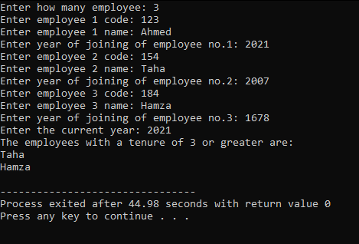

# **Question #6**

#include <stdio.h>

struct courses

{

char coursename[100];

float GPA;

};

struct address

{

char strtads[100];

char city[100];

char state[100];

int zip;

};

struct stddata

{

float CGPA;

struct courses c;

struct address a;

};

int main()

{

struct stddata s[2];

for(int i = 0 ; i < 2 ; i++)

{

printf("Enter the CGPA of student %d: ",i+1);

scanf("%f",&s[i].CGPA);

printf("Enter the course name: ");

getchar();

gets(s[i].c.coursename);

printf("Enter the course GPA: ");

scanf("%d",&s[i].c.GPA);

printf("Enter street address: ");

getchar();

gets(s[i].a.strtads);

printf("Enter city: ");

getchar();

gets(s[i].a.city);

printf("Enter state: ");

getchar();

gets(s[i].a.state);

printf("Enter zip: ");

scanf("%d",&s[i].a.zip);

}

if (s[0].c.GPA > s[1].c.GPA)

{

printf("Student %d has greater GPA than Student %d in %s\n",1,2,s[0].c.coursename);

}

else if (s[0].c.GPA < s[1].c.GPA)

{

printf("Student %d has greater GPA than Student %d in %s\n",2,1,s[1].c.coursename);

}

if (s[0].CGPA > s[1].CGPA)

{

printf("Student %d has the highest CGPA of %f\n",1,s[0].CGPA);

}

else if (s[0].CGPA < s[1].CGPA)

{

printf("Student %d has the highest CGPA of %f\n",2,s[1].CGPA);

}

}

